RFID VEHICLE ACCESS AND
BOOM BARRIER MANAGEMENT SYSTEM
Software Requirements and Operational Specification
LOCAL-FIRST | WINDOWS STANDALONE | OFFLINE CAPABLE
Document Version: 1.0
Status: Requirements Baseline for Review
Date: 11 July 2026
Prepared from the confirmed material list, operating rules, UI reference, and RFID vehicle master sample supplied by the client.

Document Control
Item | Value
Document title | RFID Vehicle Access and Boom Barrier Management System - Software Requirements and Operational Specification
Version | 1.0
Purpose | Define the complete functional, operational, interface, configuration, logging, synchronization, and acceptance requirements for the Windows standalone software.
Primary operator | Administrator / device operator
Target platform | Windows PC with a UI suitable for a 15-inch monitor
Current release scope | RFID, vehicle sensors, RTSP cameras, barriers, signal lights, buzzers, local database, Excel/CSV import, MQTT synchronization, FTP/SFTP image upload, logs, admin tools
Deferred scope | External display system and audio announcement system

Review instruction: This document is written as a human-readable baseline. Each requirement can be checked and approved during review. Any hardware-specific protocol detail not yet supplied is listed in Section 23.

Contents
1. Executive Summary
2. Scope and Design Principles
3. Hardware and Interfaces
4. System Architecture
5. User Role and Access
6. RFID and Vehicle Master Data
7. Common Processing Rules
8. IN Lane Operation
9. OUT Lane Operation
10. Sensors, Timers and Lane States
11. Serial Commands and Hardware Control
12. Camera and Image Handling
13. Local Database, Offline Operation and Multi-Site Rules
14. Server Communication and Synchronization
15. User Interface Requirements
16. Administrative and Manual Operations
17. Status Log, Server Log and Audit Trail
18. Configuration Requirements
19. Error Handling and Recovery
20. Data Records
21. Security and Reliability
22. Acceptance Criteria
23. Pending Technical Inputs
Appendix A. Command Reference
Appendix B. Import File Mapping
Appendix C. Recommended UI Messages

1. Executive Summary
The required product is a Windows-based standalone application that manages vehicle entry and exit using RFID identification, vehicle-presence sensors, RTSP cameras, boom barriers, signal lights, and buzzers. The software performs all real-time gate decisions locally and does not wait for the remote server.
Most important operating principle: The gate must continue to operate when the internet, MQTT broker, FTP/SFTP server, or remote application is unavailable. Transactions and images are stored locally and synchronized later.

- A registered RFID identifies the vehicle and displays its vehicle number in the application.
- An unregistered RFID displays NOT REGISTERED and does not open the barrier.
- A vehicle must be detected by the corresponding IN or OUT sensor before its RFID is processed.
- Paid RFID vehicles are charged only at entry. Free RFID vehicles are never charged.
- A paid RFID with a non-negative but insufficient balance receives one final entry and becomes negative. A card already negative is rejected.
- Exit is permitted only when a matching active IN trip exists. No amount is debited at exit.
- Both camera live feeds remain visible. Snapshots are taken after the configured process-wait time.
- Status Log and Server Log are always maintained separately.
ID | Requirement | Verification
SYS-001 | The application shall be a Windows standalone desktop application. | Install and launch on the target Windows PC.
SYS-002 | Real-time gate processing shall not depend on a server response. | Disconnect network and complete valid IN/OUT tests.
SYS-003 | The application shall support one IN lane and one OUT lane. | Verify separate readers, cameras, sensors and barrier commands.
SYS-004 | The UI shall be usable on a 15-inch monitor. | Review at the selected production resolution.

2. Scope and Design Principles

2.1 Included in Version 1
- IN and OUT RFID reading through separate serial ports.
- Vehicle-presence detection through control-unit messages.
- IN and OUT boom barrier control.
- Separate IN and OUT red, orange and green signal-light control.
- Separate IN and OUT buzzer control.
- Two continuous RTSP camera live feeds and transaction snapshots.
- Registered vehicle identification and vehicle-number display.
- Paid and free RFID processing.
- Excel/CSV import of vehicle and RFID records.
- Local transaction processing, local storage and offline queues.
- Background MQTT/MQTTS synchronization and FTP/SFTP image uploading.
- Administrator configuration, manual controls, correction screens and audit history.
- Separate Status Log and Server Log panels.

2.2 Deferred for Future Versions
- External driver-facing display hardware.
- Audio announcements or text-to-speech.

2.3 Design Principles
Principle | Meaning
Local first | Vehicle processing, balance decision, trip creation and hardware control occur locally.
Fail operational | Network or server faults must not stop valid local gate operation.
Traceable | Every automatic and manual action is logged with time and outcome.
Configurable | Ports, rates, timers, prefixes, camera details and server credentials are editable.
Idempotent synchronization | Retrying the same transaction must not create duplicate server records.
Clear operator feedback | The UI must show vehicle number, registration status, lane status, hardware status and errors.

3. Hardware and Interfaces
No. | Material | Purpose / Interface
1 | IN RFID Reader | Reads the RFID of a vehicle at the entrance. Connected through a configurable COM port.
2 | OUT RFID Reader | Reads the RFID of a vehicle at the exit. Connected through a configurable COM port.
3 | RFID Tags | Uniquely identify registered vehicles and link them to paid/free status and balance.
4 | Windows PC | Runs the standalone application, local database, RTSP live view and background synchronization.
5 | IN Boom Barrier | Opens and closes the entrance lane.
6 | OUT Boom Barrier | Opens and closes the exit lane.
7 | IN Camera | Provides entrance live feed and captures the IN transaction image.
8 | OUT Camera | Provides exit live feed and captures the OUT transaction image.
9 | Monitor | Displays the application UI; design target is a 15-inch monitor.
10 | Audio System | Deferred from Version 1.
11 | Signal Light System | Provides separate IN/OUT red, orange and green guidance.
12 | Display System | Deferred from Version 1.
13 | IN Vehicle Sensor | Confirms a vehicle is physically present in the entrance processing area.
14 | OUT Vehicle Sensor | Confirms a vehicle is physically present in the exit processing area.
15 | Control Unit | Receives barrier/light/buzzer commands and sends sensor detection messages through one COM port.

3.1 Required Communications
Connection | Direction | Content
IN RFID COM | Reader -> PC | IN RFID tag data
OUT RFID COM | Reader -> PC | OUT RFID tag data
Control COM | Both directions | PC sends barrier/light/buzzer commands; control unit sends IN Detected and OUT Detected.
IN RTSP | Camera -> PC | Continuous live video and snapshot source
OUT RTSP | Camera -> PC | Continuous live video and snapshot source
MQTT/MQTTS | Both directions | Master data, balance data, transaction data, synchronization status and optional remote configuration/commands
FTP or SFTP | PC -> image server | Captured vehicle images

4. System Architecture
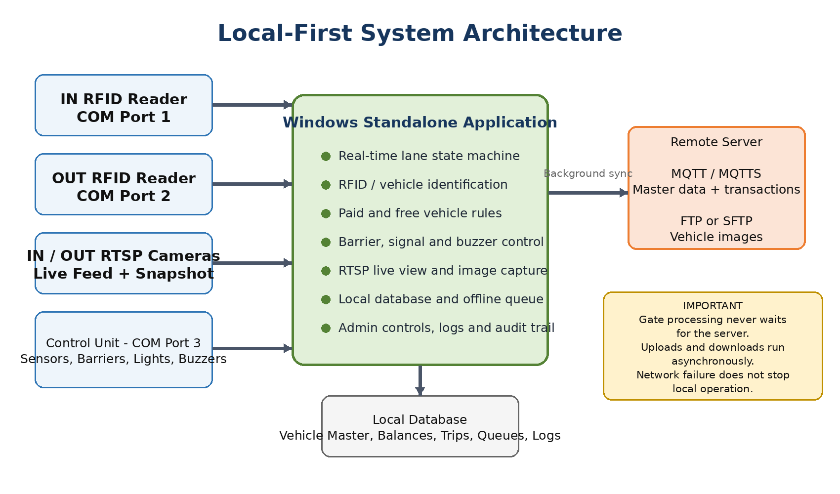
Figure 1 - Local-first architecture. The remote server is asynchronous and is not in the barrier-control decision path.

4.1 Processing Boundary
The Windows application owns the real-time lane workflow. It shall maintain a local copy of registered vehicles, RFID type, the latest synchronized balance, active trips, local debits, captured image paths, pending messages, pending image uploads, configuration, logs and audit records.

4.2 Server Authority Without Server Dependency
The server remains the master source for the consolidated balance and master data across sites. Each device maintains a synchronized operational mirror. The device uses that mirror for immediate gate decisions and sends locally completed transactions to the server in the background.
Balance safety rule: A balance download must never erase a local debit that has not yet been accepted by the server. The local effective balance must include all pending local debits until synchronization and reconciliation are complete.

5. User Role and Access
The installed device is operated by an administrator/operator. Version 1 may use a single administrator role, but all sensitive actions shall still be logged.
Capability | Admin / Operator
Run automatic IN/OUT processing | Allowed
View live cameras and status | Allowed
Open/close barriers manually | Allowed and audit logged
Test lights and buzzers | Allowed and audit logged
Import or edit RFID/vehicle data | Allowed and audit logged
Edit COM, camera, MQTT, FTP/SFTP and timer settings | Allowed and audit logged
Correct or close unmatched trips | Allowed with mandatory reason
Resolve synchronization conflicts | Allowed with mandatory reason
Delete records permanently | Not recommended; use cancel/void with audit history

6. RFID and Vehicle Master Data

6.1 Vehicle Identification
Each accepted RFID shall map to one registered vehicle. When detected, the associated vehicle number shall be displayed prominently in the Vehicle Number panel. Unknown tags shall display NOT REGISTERED.
ID | Requirement | Verification
RFID-001 | The application shall validate that a tag starts with one of the configured RFID prefixes. | Read one allowed tag and one disallowed tag.
RFID-002 | The allowed prefix list and case-sensitivity rule shall be editable. | Modify settings and repeat a read test.
RFID-003 | A registered RFID shall display its vehicle number. | Read an imported RFID and compare to master data.
RFID-004 | An unregistered RFID shall display NOT REGISTERED and shall not open the barrier. | Read an unknown tag with vehicle sensor active.
RFID-005 | The same tag repeatedly reported by a reader shall be ignored during a configurable duplicate-read interval. | Continuously present the tag and verify only one process starts.

6.2 Paid and Free RFID Types
RFID Type | Entry Rule | Exit Rule
FREE | No amount is debited. All other validation, image, trip and barrier operations are performed. | Allowed only with a matching IN trip. No debit.
PAID | Apply the configured entry fee against the local effective balance. | Allowed only with a matching IN trip. No debit.

6.3 Excel / CSV Import
The application shall import both .xlsx and .csv files. The uploaded sample vehicle master contains the columns shown below. The import screen shall allow the operator to choose a default RFID type when the file does not contain a paid/free column.
Sample Column | Application Mapping | Required
sno | Source serial/reference number | No
username | Source site, customer, yard or access group | No
vehicle_no | Vehicle number displayed in the UI | Yes
rf_id | RFID tag number used for identification | Yes
empty_weight | Optional reference field retained for future use | No
rfid_type | Optional FREE or PAID classification | No - import default may be selected
active | Optional active/inactive status | No - default Active

- Trim spaces and normalize RFID and vehicle-number values before comparison.
- Reject blank RFID numbers and blank vehicle numbers.
- Merge exact duplicate rows without creating duplicate vehicle records.
- When the same RFID maps to different vehicle numbers, mark the rows as conflicts and do not silently overwrite.
- Allow the same registered vehicle to be authorized at multiple sites/devices through site authorization data.
- Show imported, updated, unchanged, rejected and conflict counts.
- Allow export of rejected/conflicting rows for correction.
- Maintain an import history containing filename, date/time, operator and result counts.

7. Common Processing Rules
Condition | Required Action
Corresponding vehicle sensor is not active | Ignore the RFID for gate processing. Log the reason.
RFID prefix is invalid | Ignore the RFID. Do not create a trip and do not open the barrier.
RFID is not registered | Display NOT REGISTERED, log it, and keep the barrier closed.
RFID is inactive/blocked | Display BLOCKED or INACTIVE and keep the barrier closed.
Same RFID read again within duplicate interval | Ignore the repeated read.
Valid transaction | Save locally before or at the time of issuing the barrier-open command.
Server unavailable | Continue local processing and queue synchronization.
Camera unavailable | Show camera error, log snapshot failure, continue the valid gate process, and mark image status as failed/pending manual correction.
Hardware command port unavailable | Do not claim that the barrier opened. Show a critical local error and allow the operator to retry or use manual recovery.

7.1 Paid Entry Balance Decision
Current Effective Balance | Configured Entry Fee | Decision | New Local Balance
Greater than or equal to fee | Any positive configured amount | Allow entry and debit fee | Balance - fee
Zero or positive but less than fee | Greater than balance | Allow one final entry | Balance - fee (negative)
Already negative | Any amount | Reject entry | No change

7.2 Worked Balance Examples
Balance Before | Entry Fee | Result | Balance After
100 | 30 | Entry approved; debit 30 | 70
20 | 30 | One-time low-balance entry approved | -10
0 | 30 | One-time low-balance entry approved | -30
-1 | 30 | Entry rejected; card already negative | -1

7.3 Local Commit Safety
For an approved paid entry, the balance adjustment and the IN transaction shall be committed together in one local database operation before the application treats the entry as recorded. A FREE transaction follows the same record flow with a debit amount of zero. If the local database cannot save the transaction, the automatic barrier-open sequence shall not be issued.

8. IN Lane Operation
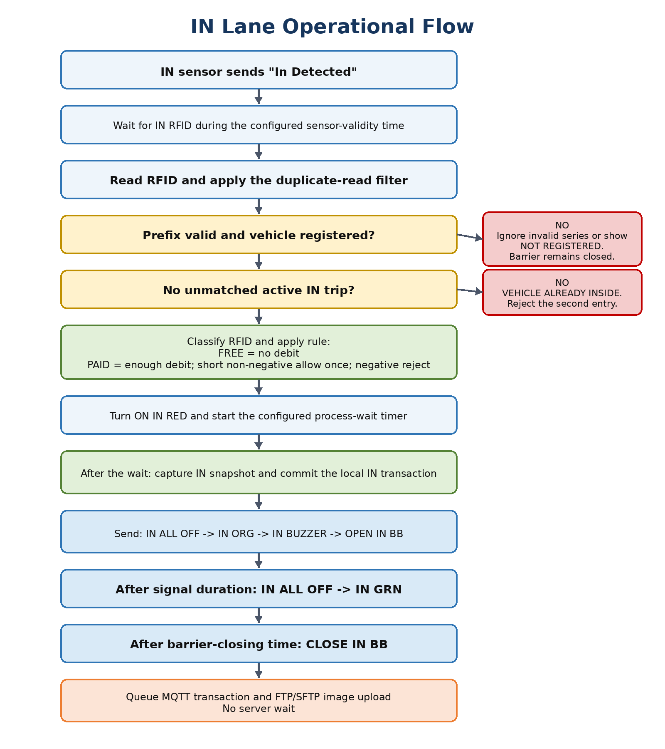
Figure 2 - Entrance processing flow.

8.1 Detailed Sequence
1. The control unit sends "IN Detected" when a vehicle is physically present in the IN area.
2. The application marks the IN lane as vehicle-present and starts the configurable sensor-validity timer.
3. The IN RFID reader sends the tag number.
4. The application validates the RFID prefix and duplicate-read interval.
5. The application looks up the vehicle in the local registered-vehicle database.
6. If the vehicle is not registered, inactive, or already has an unmatched IN trip, the barrier remains closed and the reason is displayed and logged.
7. For a valid vehicle, the application displays the vehicle number, RFID type and current local balance/free status.
8. The application sends IN RED and starts the configurable process-wait timer.
9. For a FREE RFID, debit amount is zero. For a PAID RFID, the local balance rule in Section 7.1 is applied.
10. After the process-wait timer completes, the application captures an image from the IN RTSP stream.
11. The application creates and commits the local IN transaction, including balance result and image status.
12. The application sends IN ALL OFF, IN ORG, IN BUZZER and OPEN IN BB.
13. After the configured signal/buzzer duration, the application sends IN ALL OFF and IN GRN.
14. After the configured barrier-closing time, the application sends CLOSE IN BB.
15. The transaction and image upload tasks are queued for background synchronization.
ID | Requirement | Verification
IN-001 | IN processing shall require a valid IN Detected state. | Read an RFID without sensor detection; verify no trip.
IN-002 | A vehicle with an active unmatched IN trip shall be rejected as already inside. | Attempt a second entry for the same RFID.
IN-003 | The entry fee shall be editable. | Change fee and verify resulting debit.
IN-004 | FREE RFID entry shall create a full trip with zero debit. | Process a free RFID and inspect record.
IN-005 | The snapshot shall be attempted after the configured process-wait time. | Compare RFID timestamp and snapshot attempt timestamp.

9. OUT Lane Operation
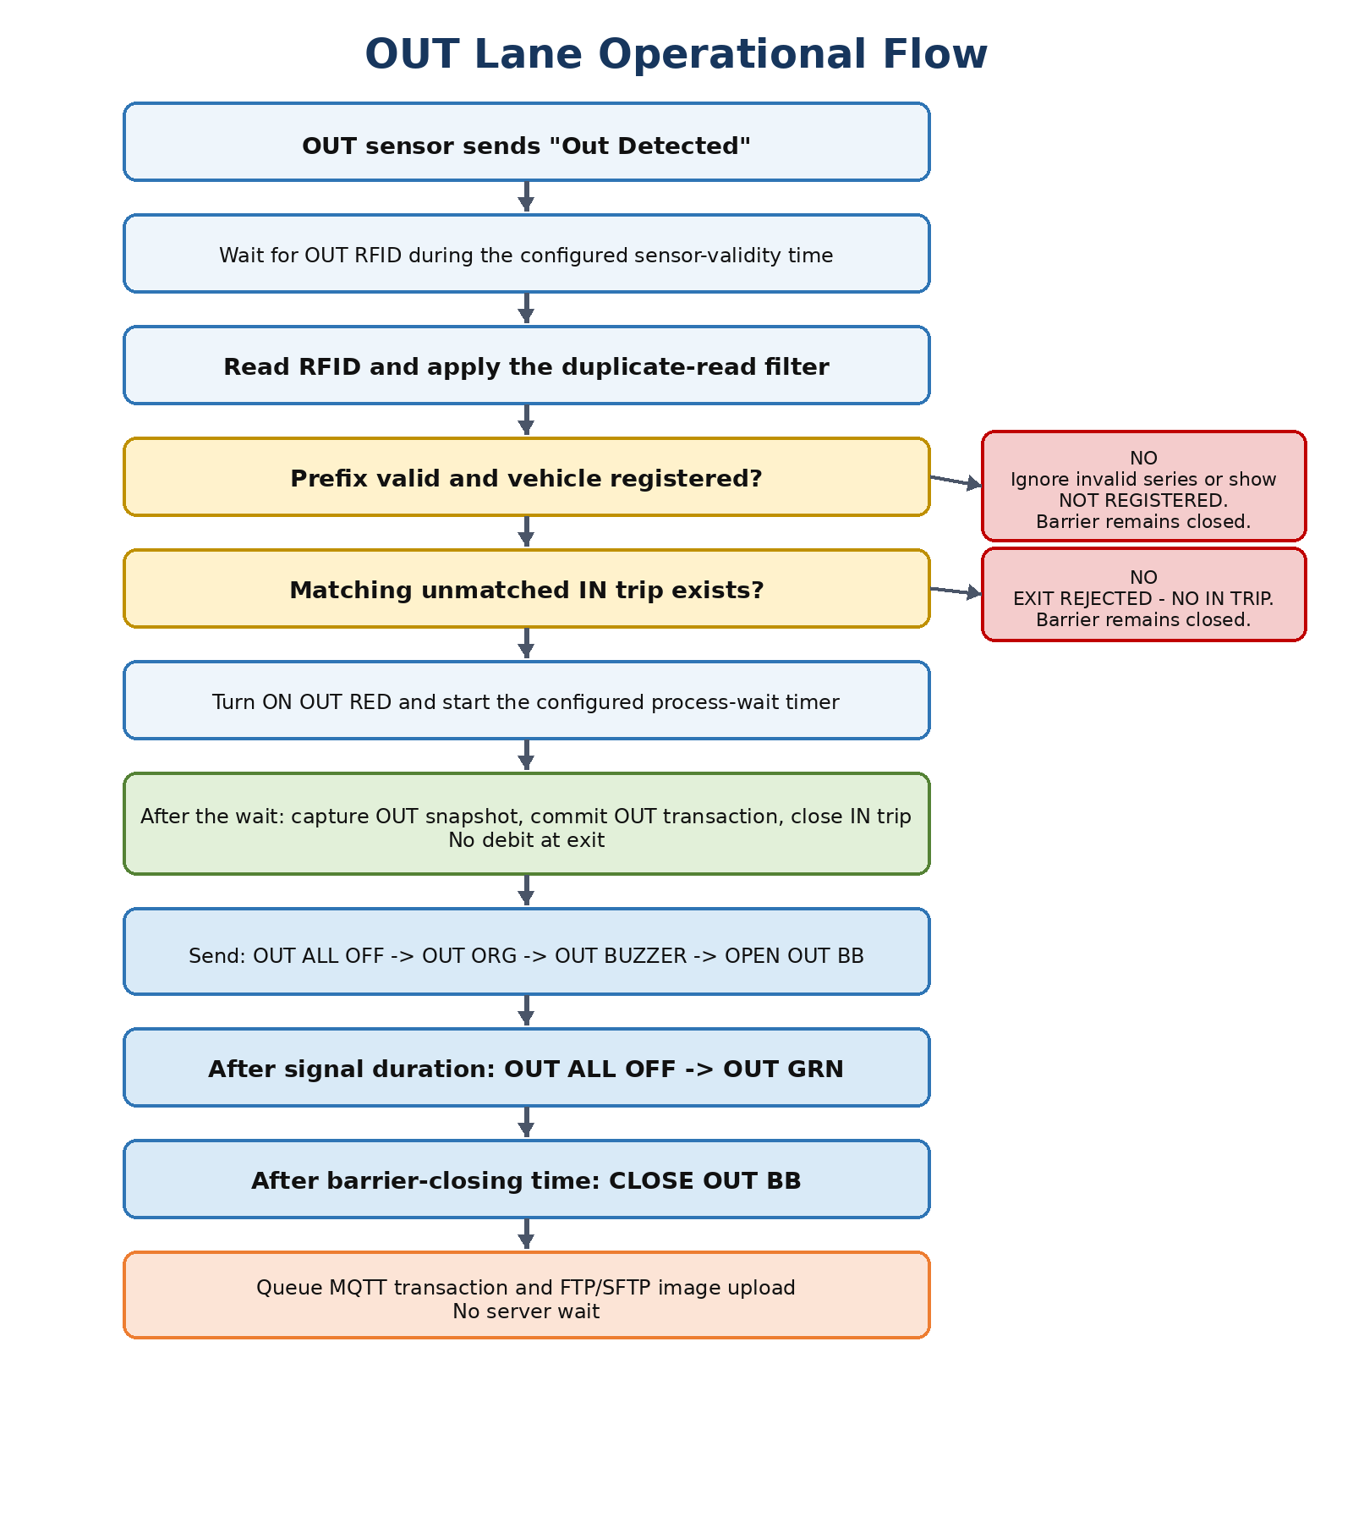
Figure 3 - Exit processing flow.

9.1 Detailed Sequence
1. The control unit sends "OUT Detected" when a vehicle is physically present in the OUT area.
2. The application marks the OUT lane as vehicle-present and starts the configurable sensor-validity timer.
3. The OUT RFID reader sends the tag number.
4. The application validates the RFID prefix, duplicate-read interval and local vehicle registration.
5. The application searches for a valid unmatched IN trip for the RFID.
6. If no matching IN trip exists, the barrier remains closed and the UI displays NO IN TRIP / EXIT REJECTED.
7. For a valid exit, the application displays the vehicle number and sends OUT RED.
8. The configurable process-wait timer starts.
9. After the timer completes, the application captures an image from the OUT RTSP stream.
10. The application creates and commits the local OUT transaction and closes the matching IN trip. No amount is debited.
11. The application sends OUT ALL OFF, OUT ORG, OUT BUZZER and OPEN OUT BB.
12. After the configured signal/buzzer duration, the application sends OUT ALL OFF and OUT GRN.
13. After the configured barrier-closing time, the application sends CLOSE OUT BB.
14. The OUT transaction and image upload tasks are queued for background synchronization.
ID | Requirement | Verification
OUT-001 | OUT processing shall require a valid OUT Detected state. | Read an RFID without OUT sensor detection.
OUT-002 | Exit shall require a matching unmatched IN trip. | Attempt exit for a vehicle with no IN trip.
OUT-003 | No amount shall be debited during OUT processing. | Compare balance before and after exit.
OUT-004 | A successful OUT trip shall close the corresponding active IN trip. | Inspect trip state after exit.

10. Sensors, Timers and Lane States

10.1 Sensor Messages
Message from Control Unit | Meaning | Application Action
IN Detected | Vehicle present in entrance processing area | Set IN lane vehicle-present state and start sensor-validity timer.
OUT Detected | Vehicle present in exit processing area | Set OUT lane vehicle-present state and start sensor-validity timer.

10.2 Editable Timers
Timer | Starts When | Purpose
RFID duplicate-ignore time | A tag is accepted from a reader | Prevents continuous reader output from creating repeated transactions.
Sensor-validity time | IN Detected or OUT Detected is received | Limits how long the application will accept an RFID for that detected vehicle.
Process-wait time | A valid RFID is accepted | Wait period before snapshot and final valid transaction action.
Signal/buzzer duration | Barrier-open command sequence is issued | Controls how long orange and buzzer remain active before green.
Barrier-closing time | Barrier-open command is issued | Controls when CLOSE IN BB or CLOSE OUT BB is sent.
UI reset time | Transaction is completed/rejected | Controls how long the latest vehicle result remains visible.
COM reconnect interval | A COM port disconnects | Controls automatic reconnection attempts.
Camera reconnect interval | An RTSP stream fails | Controls automatic camera reconnection attempts.
Server retry interval | Upload/download fails | Controls asynchronous MQTT/FTP/SFTP retry.

10.3 Lane State Model
State | Description
IDLE / GREEN | Lane ready; green signal is on unless configured otherwise.
VEHICLE DETECTED | Sensor is active; application is waiting for RFID.
RFID VALIDATING / RED | RFID is being checked; red signal is on.
PROCESS WAIT | Valid processing timer is running.
OPENING / ORANGE + BUZZER | Barrier-open command issued; orange and buzzer active.
PASSAGE / GREEN | Configured signal time completed; green signal active.
CLOSING | Close command issued based on configured closing time.
REJECTED / ERROR | Barrier remains closed; reason is shown in UI and Status Log.

11. Serial Commands and Hardware Control

11.1 Required Control Commands
Command | Purpose
OPEN IN BB | Open the IN boom barrier.
CLOSE IN BB | Close the IN boom barrier.
OPEN OUT BB | Open the OUT boom barrier.
CLOSE OUT BB | Close the OUT boom barrier.
IN RED | Turn on the IN red signal light.
IN GRN | Turn on the IN green signal light.
IN ORG | Turn on the IN orange signal light.
IN BUZZER | Turn on the IN buzzer.
IN ALL OFF | Turn off all IN signal lights and the IN buzzer.
OUT RED | Turn on the OUT red signal light.
OUT GRN | Turn on the OUT green signal light.
OUT ORG | Turn on the OUT orange signal light.
OUT BUZZER | Turn on the OUT buzzer.
OUT ALL OFF | Turn off all OUT signal lights and the OUT buzzer.

No hardware acknowledgement: The control unit cannot confirm command execution. The UI must therefore show Last Command Sent rather than claiming a barrier or signal is physically in the requested state.

ID | Requirement | Verification
COM-001 | The IN RFID, OUT RFID and control unit shall use three independently configurable COM ports and baud rates. | Open configuration and connect all three ports.
COM-002 | Serial settings shall include data bits, parity, stop bits, line ending/read framing and reconnect interval. | Change settings and verify reconnect.
COM-003 | Every command attempt and serial error shall be written to the Status Log. | Send manual commands and disconnect port.
COM-004 | Commands for IN and OUT lights/buzzers shall be lane-specific. | Verify exact text sent for each lane.

12. Camera and Image Handling

12.1 Live View
- The IN and OUT RTSP live feeds shall always be displayed on the main screen.
- Each camera panel shall show connection state and a clear offline/authentication/stream error overlay.
- The application shall automatically attempt reconnection at the configured interval.
- Camera details, username, password, RTSP URL and preferred capture resolution shall be editable.

12.2 Snapshot Timing and Storage
- A transaction snapshot shall be attempted after the configured process-wait time completes.
- The image shall first be written to local storage before any remote upload is attempted.
- The image filename shall include a unique transaction ID so retries cannot create ambiguity.
- Recommended local path: Images/{SiteId}/{yyyy}/{MM}/{dd}/{IN-or-OUT}/{TransactionId}.jpg.
- The transaction shall store image path, capture timestamp, capture status, upload status and remote path when available.

12.3 Camera Failure
A camera failure shall be visible in the camera panel and Status Log. A valid RFID transaction may continue so that the gate remains operational. The record shall be marked Image Capture Failed, and the administrator may later attach or correct the image if required.

13. Local Database, Offline Operation and Multi-Site Rules

13.1 Local Database Responsibilities
- Store the registered vehicle/RFID master and site authorizations.
- Store the latest server balance snapshot and its version/time.
- Store local paid/free classification and active status.
- Store active IN trips, completed OUT trips and rejected attempts.
- Store all local balance adjustments and pending synchronization records.
- Store image metadata, local file paths and upload status.
- Store application settings, logs, audit records and import history.

13.2 Offline Processing
1. Use the latest local registered-vehicle and balance data.
2. Apply the full IN or OUT rule locally.
3. Save the transaction and balance result locally.
4. Control the barrier, lights and buzzer without waiting for network recovery.
5. Mark transaction and image as pending synchronization.
6. Automatically retry when the corresponding connection is restored.

13.3 Multi-Site Balance Reconciliation
The same vehicle may use different sites or devices. When multiple sites operate offline, two devices can temporarily process the same server balance. This cannot be fully prevented without requiring an online approval, which is intentionally excluded from the gate path. The system shall therefore preserve every local transaction and use reconciliation statuses rather than silently discarding data.
Server Result | Local Action
Accepted | Mark the transaction synchronized and update the server balance baseline/version.
Duplicate / already processed | Mark synchronized using the same unique transaction ID; do not create a second debit.
Conflict / insufficient consolidated balance | Mark Reconciliation Required. Do not automatically erase the completed local trip.
Rejected because master data changed | Mark Reconciliation Required and show it to the administrator.
No response | Keep pending and retry according to policy.

Effective local balance: The balance displayed and used for processing shall equal the last accepted server balance adjusted by local transactions that have not yet been reflected in that server balance.

14. Server Communication and Synchronization

14.1 MQTT / MQTTS
The production application shall use an MQTT client library. MQTTX may be used by developers and operators to test the broker, topics and payloads; it is not the embedded runtime communication component.
- Broker host, port, TLS mode, username, password, client ID, keep-alive, QoS and retry settings shall be editable.
- Every device shall have SiteId and DeviceId values included in messages.
- Every transaction shall have a globally unique transaction ID.
- Transaction uploads shall be idempotent so repeated delivery cannot create duplicate debits or trips.
- MQTT disconnects and retries shall be written only to the Server Log, except critical user-visible alarms.

14.2 Master and Balance Download
- The application shall support downloading all registered RFID balances every one minute by default.
- The synchronization interval shall be editable.
- The design should also support version/delta synchronization for performance when the dataset becomes large.
- Downloaded data shall be applied safely without overwriting pending local transactions.
- A full synchronization may also run when the application starts and when connectivity returns.

14.3 Image Upload
Mode | Requirement
Disabled | Keep images locally and show them as not configured for upload.
FTP | Use configured FTP host, port, credentials, remote directory and retry settings.
SFTP | Use configured SFTP host, port, credentials/key settings, remote directory and retry settings.

Configuration rule: Only one image-upload mode shall be active at a time: Disabled, FTP or SFTP.

14.4 Suggested Message Categories
Category | Examples
Device status | Online/offline, application version, COM/camera health, pending counts
Master synchronization | Vehicle records, paid/free type, active status, site authorization
Balance synchronization | Balance snapshot/version and reconciliation result
IN transaction | RFID, vehicle number, fee, balances, timestamps, site/device and image reference
OUT transaction | RFID, vehicle number, matched IN transaction, timestamps, site/device and image reference
Administrative correction | Changed fields, reason, operator, old/new value and time

15. User Interface Requirements
The supplied Smart Weigh Bridge screen is a visual reference for information density and layout. The new application shall use two main camera panels (IN and OUT), a right-side operational summary, and separate lower log panels.
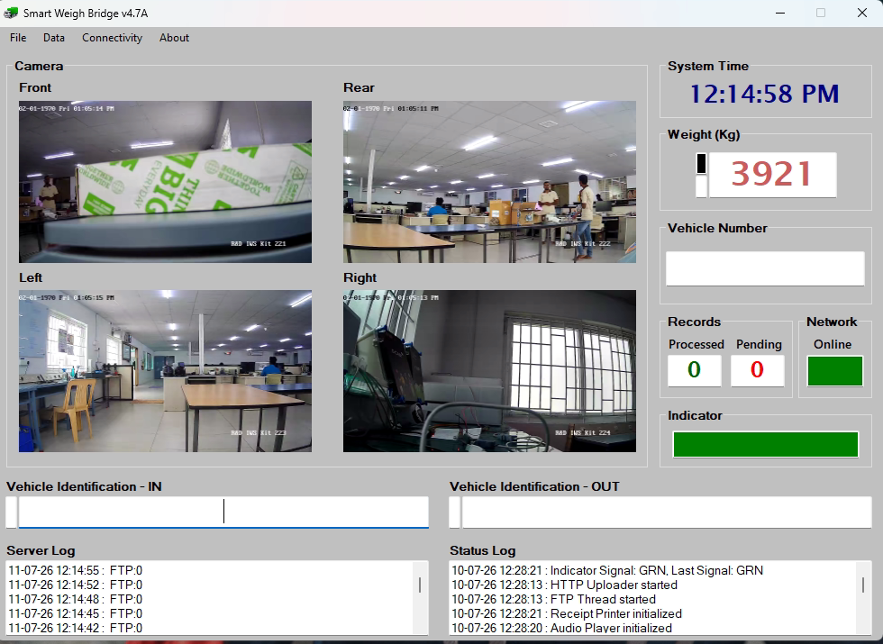
Figure 4 - Client-supplied UI reference. The new RFID application will adapt this layout to two camera feeds and gate-specific information.

15.1 Main Screen Layout
Area | Required Information
Top-left | IN camera live feed, camera status and latest IN result overlay.
Top-center/right | OUT camera live feed, camera status and latest OUT result overlay.
Right summary panel | System time, vehicle number, RFID number/status, FREE/PAID, balance/debit, approval result, network and synchronization counts.
IN identification panel | Latest IN RFID, sensor state, process state and message.
OUT identification panel | Latest OUT RFID, sensor state, process state and message.
Bottom-left | Status Log for local hardware and process events.
Bottom-right | Server Log for MQTT, master/balance sync and FTP/SFTP activity.
Menu / admin controls | Data import, configuration, connectivity tests, manual hardware control, corrections, reports and About.

15.2 Vehicle Number Display
- The vehicle number shall be large and readable from the operator position.
- A registered tag shows the vehicle number and its current status.
- An unknown tag shows NOT REGISTERED.
- A blocked tag shows BLOCKED / INACTIVE.
- A duplicate active IN trip shows VEHICLE ALREADY INSIDE.
- An exit without an IN trip shows NO IN TRIP / EXIT REJECTED.

15.3 Status Indicators
Indicator | States
IN RFID COM | Connected / disconnected / reconnecting
OUT RFID COM | Connected / disconnected / reconnecting
Control COM | Connected / disconnected / reconnecting
IN camera | Live / reconnecting / offline / authentication error
OUT camera | Live / reconnecting / offline / authentication error
MQTT | Connected / disconnected / retrying
FTP/SFTP | Connected or ready / disabled / error / retrying
IN sensor | Vehicle detected / clear / timed out
OUT sensor | Vehicle detected / clear / timed out
Records | Processed today / pending transactions / pending images / reconciliation required

16. Administrative and Manual Operations
Function | Required Behavior
Manual barrier control | Open/close IN and OUT barriers. Require confirmation for opening and audit the action.
Light/buzzer test | Individually send IN/OUT red, green, orange, buzzer and all-off commands.
Camera tools | View status, reconnect, test snapshot and open local image folder.
COM tools | Refresh ports, connect/disconnect, test reader input and send control command.
Import vehicle master | Import Excel/CSV, preview mappings, choose default FREE/PAID, validate and report errors.
Vehicle maintenance | Add/edit/deactivate RFID, vehicle number, type, balance snapshot and site authorization.
Trip correction | Close/cancel unmatched trip, correct vehicle/RFID association, retry upload or mark void with reason.
Conflict resolution | Review server reconciliation results and record the operator decision.
Data export | Export transactions, pending records, conflicts and logs to Excel/CSV.
Configuration backup | Export and import non-secret settings with validation.

Audit rule: Manual changes shall preserve the original record. The system should use corrected/voided statuses and an audit history rather than silently replacing historical values.

17. Status Log, Server Log and Audit Trail

17.1 Status Log
The Status Log is for local device operation. It shall remain separate from the Server Log.
- Sensor messages and sensor timeout.
- RFID reads, invalid prefixes, duplicate reads and registration result.
- Vehicle number, paid/free classification and balance decision.
- Process-wait timer, snapshot result and local database result.
- Barrier, signal and buzzer command attempts.
- COM connection and serial errors.
- Camera connection and capture errors.
- Manual operator actions affecting local processing.

17.2 Server Log
- MQTT connection, subscriptions, publications, acknowledgements and retries.
- Vehicle/balance download start, completion and record counts.
- Transaction upload success/failure and reconciliation result.
- FTP/SFTP connection and image upload status.
- Pending transaction and image counts.
- Network connectivity changes and background retry scheduling.

17.3 Log Format and Retention
Field | Requirement
Timestamp | Local date/time with milliseconds when useful.
Level | Information, Warning, Error or Critical.
Source | IN lane, OUT lane, COM, camera, local database, MQTT, FTP/SFTP, import or admin.
Message | Human-readable action or failure.
Reference | RFID, transaction ID, image ID or command when applicable.
Retention | Configurable file/database retention with automatic archival or cleanup.

18. Configuration Requirements
All configuration shall be editable through an administrator screen and stored locally. Sensitive credentials shall not be displayed as plain text after saving.
Configuration Group | Editable Values
Device identity | Site ID, Device ID, lane/site name, application name
IN RFID serial | COM port, baud rate, data bits, parity, stop bits, read timeout, framing/line ending, reconnect interval
OUT RFID serial | COM port, baud rate, data bits, parity, stop bits, read timeout, framing/line ending, reconnect interval
Control serial | COM port, baud rate, data bits, parity, stop bits, write timeout, line ending, reconnect interval
RFID validation | Enable/disable, one or more accepted prefixes, case sensitivity, duplicate-ignore time
Paid processing | Entry fee and negative-balance rule enablement
Timing | Sensor-validity time, process-wait time, signal/buzzer duration, IN/OUT closing time, UI reset time
IN camera | RTSP URL, username, password, transport option, snapshot resolution, reconnect interval
OUT camera | RTSP URL, username, password, transport option, snapshot resolution, reconnect interval
MQTT | Host, port, TLS, certificates, username, password, client ID, topics, QoS, keep alive, timeout, retry interval
Master synchronization | Full-download interval, startup sync, reconnect sync, optional delta/version mode
Image upload | Mode Disabled/FTP/SFTP, host, port, credentials/key, remote directory, retry interval
Local storage | Database path, image root, backup path, log path, retention and disk-space thresholds
UI | Date/time format, vehicle display reset time, full-screen/startup behavior

ID | Requirement | Verification
CFG-001 | Settings shall be validated before saving. | Enter invalid COM port, URL, port or negative timer.
CFG-002 | Changes that require reconnect/restart shall be clearly identified. | Change a COM/camera setting while running.
CFG-003 | A configuration test shall be available for COM, camera, MQTT and FTP/SFTP. | Run each test from settings.
CFG-004 | Configuration changes shall be audit logged. | Change a timer and inspect audit history.

19. Error Handling and Recovery
Failure | Expected Recovery
IN or OUT RFID COM disconnected | Show disconnected indicator, write Status Log, retry connection, and do not process that reader until data is valid.
Control COM disconnected | Show critical indicator, write Status Log, prevent automatic claims of barrier success, allow reconnect/manual recovery.
Camera disconnected | Show error overlay, retry stream, mark snapshot failed if required, continue valid gate processing.
Local database write fails | Do not open barrier automatically because the transaction cannot be reliably recorded; show critical error.
MQTT disconnected | Continue local operation, queue records and retry in background.
FTP/SFTP disconnected | Continue local operation, retain images locally and retry upload.
Disk space low | Show warning before critical threshold; stop unsafe image/database operations at critical threshold.
Application restarts during active process | Recover committed trips and pending queues. Reset uncertain lane state safely and log the restart.
Duplicate transaction upload | Server/client shall identify the unique transaction ID and avoid duplicate processing.
Balance conflict from another site | Mark reconciliation required and preserve the completed local transaction.
Invalid imported row | Reject row, show reason and allow error export.

20. Data Records

20.1 Vehicle / RFID Master Record
Field Group | Examples
Identity | RFID number, vehicle number, source serial number
Classification | FREE/PAID, active/blocked, vehicle type, site/access group
Balance | Last server balance, server version/time, effective local balance
Optional source fields | Username/site/customer, empty weight, remarks
Audit | Created, updated, imported from file, operator and source device

20.2 Trip / Transaction Record
Category | Required Fields
Identifiers | Transaction ID, site ID, device ID, lane, IN/OUT type, matching IN transaction ID for OUT
Vehicle | RFID number, vehicle number, FREE/PAID and registration status
Balance | Balance before, entry fee, debit amount, balance after, offline/online processing flag
Timing | Sensor time, RFID time, process start/end, snapshot time, barrier command times, local commit time
Image | Local path, capture status, upload mode, remote path and upload status
Synchronization | Pending/sent/accepted/conflict/reconciliation status, attempts, last error, server time/version
Correction | Void/corrected status, reason, operator and linked audit entries

21. Security and Reliability
- MQTT credentials, FTP/SFTP passwords, camera passwords and private keys shall be encrypted or protected using Windows-supported secure storage.
- The application shall avoid writing secrets to Status Log or Server Log.
- SFTP or TLS-secured MQTT is preferred where supported by the deployment.
- Database and configuration backups shall be supported with retention and restore validation.
- The application shall use unique transaction IDs and database constraints to reduce duplicate processing.
- Critical background services shall automatically restart or reconnect after transient failure.
- Application startup shall display the readiness of all three COM ports, both cameras, local database, MQTT and image upload service.

22. Acceptance Criteria
The following checklist defines the minimum functional acceptance for Version 1. Each item should be tested with real hardware before deployment approval.
Check | ID | Acceptance Test
[ ] | AC-01 | Valid registered FREE RFID with IN sensor opens IN barrier, records zero debit and queues upload.
[ ] | AC-02 | Valid PAID RFID with enough balance debits the configured fee and opens IN barrier.
[ ] | AC-03 | PAID RFID with non-negative insufficient balance is allowed once and becomes negative.
[ ] | AC-04 | PAID RFID already negative is rejected and barrier stays closed.
[ ] | AC-05 | Unregistered RFID displays NOT REGISTERED and barrier stays closed.
[ ] | AC-06 | RFID without the corresponding sensor detection is ignored.
[ ] | AC-07 | Repeated RFID reads within duplicate interval create only one process.
[ ] | AC-08 | Second IN attempt for a vehicle already inside is rejected.
[ ] | AC-09 | Valid OUT with matching IN trip opens OUT barrier and does not debit.
[ ] | AC-10 | OUT without matching IN trip is rejected.
[ ] | AC-11 | Both RTSP live feeds remain visible and recover after a temporary disconnect.
[ ] | AC-12 | Snapshot is attempted after configured process-wait time.
[ ] | AC-13 | IN/OUT light, buzzer, open and close commands match the approved protocol.
[ ] | AC-14 | Application continues processing while MQTT and FTP/SFTP are disconnected.
[ ] | AC-15 | Pending transactions and images upload after connectivity returns without duplicates.
[ ] | AC-16 | Excel/CSV import identifies conflicts and correctly displays imported vehicle numbers.
[ ] | AC-17 | Status Log and Server Log show their respective events separately.
[ ] | AC-18 | Manual barrier and correction actions are audit logged.
[ ] | AC-19 | All editable configuration values persist after restart.
[ ] | AC-20 | UI is readable and usable on the agreed 15-inch monitor resolution.

23. Pending Technical Inputs
The functional requirements are understood. The following device-specific information is still required before final protocol implementation and hardware acceptance testing.
No. | Required Input | Why It Is Needed
1 | IN and OUT RFID reader brand/model, protocol and sample serial data | To implement framing, parsing, encoding and reader-specific behavior.
2 | RFID reader line endings, binary/ASCII format, checksum and repeated-read behavior | To create a reliable parser and duplicate filter.
3 | Final control-unit command spelling, capitalization and line ending | To send exact compatible commands.
4 | Whether IN Detected / OUT Detected are sent once or repeatedly and whether a clear message exists | To finalize sensor state and timeout rules.
5 | IN and OUT camera model, RTSP URLs, credentials and resolution page details | To validate live view, snapshot and reconnect behavior.
6 | MQTT broker details, topic names, JSON payloads, QoS, TLS certificates and server result codes | To finalize synchronization and reconciliation.
7 | FTP/SFTP server details and remote folder convention | To finalize image uploading.
8 | Production screen resolution and Windows version | To finalize UI scaling and deployment testing.
9 | Final import rules for FREE/PAID default and site authorization | To finalize the import mapping screen.

Appendix A. Command Reference
Direction | Text | Meaning
PC -> Control Unit | OPEN IN BB | Open IN boom barrier
PC -> Control Unit | CLOSE IN BB | Close IN boom barrier
PC -> Control Unit | OPEN OUT BB | Open OUT boom barrier
PC -> Control Unit | CLOSE OUT BB | Close OUT boom barrier
PC -> Control Unit | IN RED / IN GRN / IN ORG | Turn on the selected IN signal
PC -> Control Unit | IN BUZZER / IN ALL OFF | Turn on IN buzzer / turn all IN outputs off
PC -> Control Unit | OUT RED / OUT GRN / OUT ORG | Turn on the selected OUT signal
PC -> Control Unit | OUT BUZZER / OUT ALL OFF | Turn on OUT buzzer / turn all OUT outputs off
Control Unit -> PC | IN Detected | Vehicle detected in IN area
Control Unit -> PC | OUT Detected | Vehicle detected in OUT area

Protocol completion: The final line terminator, encoding and exact letter case remain subject to the hardware sample data.

Appendix B. Import File Mapping
Preferred Column | Accepted Sample Name | Validation / Default
Source Reference | sno | Optional
Site / Group | username | Optional; may map to authorization group
Vehicle Number | vehicle_no | Required; trim and normalize spaces
RFID Number | rf_id | Required; trim, normalize and validate prefix
Empty Weight | empty_weight | Optional numeric reference
RFID Type | rfid_type | Optional FREE/PAID; otherwise use import-screen default
Active | active | Optional Yes/No; default Yes
Valid From / Until | valid_from / valid_until | Optional access-period fields

Appendix C. Recommended UI Messages
Situation | Suggested Message
Registered and accepted | ACCESS APPROVED - {Vehicle Number}
Free RFID | FREE VEHICLE - NO DEBIT
Paid debit | ENTRY APPROVED - DEBIT {Amount} - BALANCE {Balance}
One-time negative allowance | LOW BALANCE - ONE-TIME ENTRY APPROVED - BALANCE {Negative Balance}
Already negative | ACCESS DENIED - NEGATIVE BALANCE
Unknown RFID | NOT REGISTERED
Invalid prefix | RFID IGNORED - INVALID SERIES
No sensor | RFID IGNORED - VEHICLE NOT DETECTED
Already inside | ACCESS DENIED - VEHICLE ALREADY INSIDE
Exit with no entry | EXIT DENIED - NO IN TRIP
Camera unavailable | CAMERA OFFLINE - RECONNECTING
Control port unavailable | CONTROL UNIT DISCONNECTED - BARRIER COMMAND NOT SENT
Server unavailable | SERVER OFFLINE - LOCAL PROCESSING ACTIVE

Review and Approval Notes
Use this page to record corrections or approval after reviewing the requirements and operations.
Reviewed by: ______________________________________________________________________
Organization: ______________________________________________________________________
Date: ______________________________________________________________________
Comments / required changes:
_________________________________________________________________________________________________________
_________________________________________________________________________________________________________
_________________________________________________________________________________________________________
_________________________________________________________________________________________________________
_________________________________________________________________________________________________________
_________________________________________________________________________________________________________
Approval status: ______________________________________________________________________

